Week 9: α- and β-adrenoceptors in the rabbit jejunum (Finkelman’s) preparation

What you MUST know before starting;
Which subtypes of adrenoceptor are expressed in the gastro-intestinal tract, in what type of cells and how do they mediate relaxation of the smooth muscle?

At which types of receptors do the following compounds act and are they agonists or antagonists?
Isoprenaline _______________ _______________
Phenylephrine _______________ _______________
Propranolol _______________ _______________
Phentolamine _______________ _______________

Introduction

The smooth muscle of the gastro-intestinal tract exhibits spontaneous contractions, which are generated by local neural circuits within the gut wall. This helps propel its contents in an oral to anal direction. The rate and force of these contractions is modulated by the activity of the sympathetic nervous system, which is inhibitory. When released from sympathetic nerves, noradrenaline acts on postjunctional α₁- and β₁-adrenoceptors to depress the spontaneous contractions.

The Finkleman’s preparation is a piece of spontaneously active rabbit isolated jejunum. Even in the absence of external stimuli, the tissue undergoes rhythmic contractions. Activation of the sympathetic nerve supply or the addition of a sympathetimometic agent to the organ bath will inhibit the rhythmic contractions.

Aims

- To investigate the pharmacological properties of the postjunctional adrenoceptors present in the smooth muscle of the rabbit isolated jejunum preparation.

- To characterise the roles of these receptors in mediating the inhibitory effect of sympathetic nerve stimulation.

Methods

You will be supplied with a short (3 - 4 cm) section of rabbit jejunum set up in Krebs-Henseleit solution at 37°C.

The sympathetic nerves run alongside the blood vessels within the mesentery around the gut (see left-hand figure). The nerve supply of the tissue is pulled through a pair of ring electrodes, which will be used to stimulate the sympathetic nerves to the muscle.
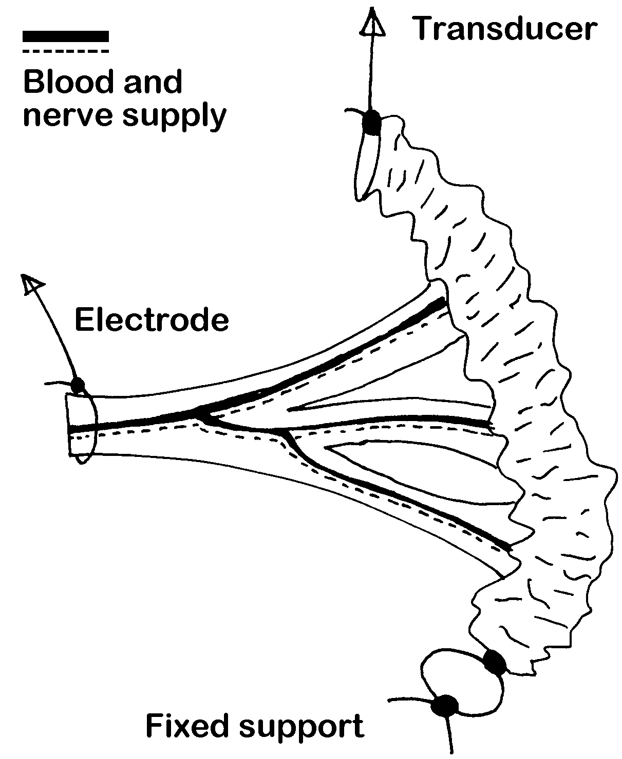
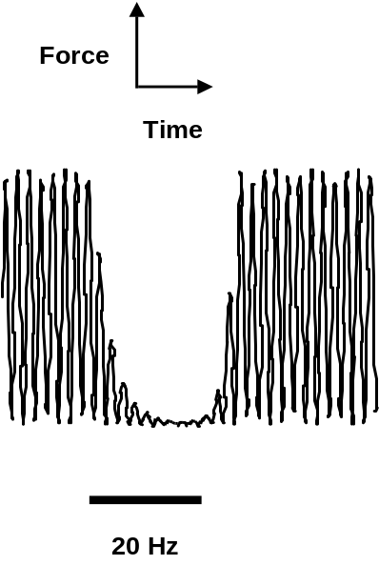

Experimental protocols

Postjunctional adrenoceptor subtypes

The muscle should contract and relax spontaneously (see figure below). Use the following treatments/drugs to inhibit these spontaneous contractions.

- Construct a cumulative concentration-response curve for the β-adrenoceptor agonist isoprenaline (10⁻⁷ - 10⁻⁵ M). Plot the data and calculate an EC₅₀ value for isoprenaline.

- Wash out isoprenaline and once the contractions have recovered add the EC₅₀ concentration of isoprenaline. Allow the contractions to stabilise at a new, smaller level. Now, without washing out the isoprenaline, reverse the inhibition by constructing a cumulative concentration-response curve for the β-adrenoceptor antagonist propranolol (10⁻⁸ - 10⁻⁶ M). Plot the data as % antagonism as follows. Take the control contraction in the absence of agonist as (a) and the response in the presence of isoprenaline as (b). (a)-(b)=(c)=inhibitory effect of isoprenaline. Measure the contractions in the presence of the first concentration of propranolol = (d). (d)-(b)=(e)=the reversal by the antagonist. For % antagonism calculate (e)/(c) x 100. Repeat for each concentration of propanolol and then plot % antagonism versus the appropriate propranolol concentration. From this plot read off an EC₇₅ value for propranolol.

- Wash out the drugs and once the contractions have stabilised, repeat the above experiments using the α₁-adrenoceptor agonist phenylephrine (10⁻⁷ - 10⁻⁵ M) and the α-adrenoceptor antagonist phentolamine (10⁻⁸ - 10⁻⁶ M).

Roles of adrenoceptor subtypes in mediating inhibitory effect of sympathetic nerve activity.

- Construct a non-cumulative frequency-response curve for sympathetic nerve stimulation (2, 4, 8, 16, 20 Hz until contractions reach steady-state level (approx. 30 - 60 sec). After each stimulation period allow the contractions to return to control values before proceeding to the next, higher frequency of stimulation.

- Plot the data (% inhibition vs frequency) and determine a frequency that gives 60-80% inhibition. Reapply this test frequency once more. Stop stimulating and allow the contractions to return to their initial level.

- Now add the IC₇₅ concentration of propranolol and incubate for 10 min.

- Reapply the test frequency of nerve stimulation in the continued presence of propranolol. By how much does this antagonise the inhibitory effect of nerve stimulation?

- Wash out the drugs and repeat the experiment using the IC₇₅ concentration of phentolamine. By how much does this antagonise the inhibitory effect of nerve stimulation?

- Wash out the drugs and repeat the experiment using the IC₇₅ concentrations of propranolol and phentolamine together. By how much does this antagonise the inhibitory effect of nerve stimulation?

